THEORY QUESTIONS

PART I

MAP SKILLS AND THE ENVIRONMENT
1.
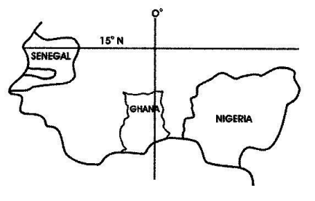
a)

On the outline map of West Africa provided, insert the following features:
i)

Accra
ii)

Lagos
iii)

River Senegal
iv)

River Volta
v)

River Niger
vi)

Jos Plateau
b)

Mention any two reasons why most rivers in West Africa are not navigable.
Show Solution
2.
a)

How are the following features shown on topographical maps?
i)

Railway
ii)

Marshy area
iii)

Court House
iv)

Mosque
v)

Market
vi)

Farm
b)

Mention two elements of the weather and the instrument used to measure each of them.

PART II

NATIONAL COMMUNITY
3.
Explain any five achievements of Sir Alan Burns in the Gold Coast.

4.
a)

Mention five types of timber found in the forests of Ghana.
b)

Give five reasons that make the timber industry important in Ghana.

PART III

WEST AFRICA, AFRICA AND THE WORLD
5.
Explain five reasons why the Moroccans defeated the Songhai Empire at the battle of Tondibi.

6.
Describe five achievements of the Organization of African Unity (OAU)

